**VISVESVARAYA TECHNOLOGICAL UNIVERSITY**

**Jnana Sangama, Belagavi – 590 014**



**A MINI PROJECT REPORT ON**

**"COURIER MANAGEMENT SYSTEM"**

Submitted in partial fulfillment of the requirements for

**DBMS MINI PROJECT [ 18CSL57 ] IN**

**5th SEM COMPUTER SCIENCE AND ENGINEERING 2020-2021**

**Submitted by:**

**Adarsh N 1GG18CS002**

**Nithin Kumar B 1GG18CS028**

**Vinayak S B 1GG18CS043**

**UNDER THE GUIDANCE OF**

**Dr.SHABEEN TAJ G A**

**Associate Professor Dept. of CS&E**

**GEC, Ramanagara.**



**DEPARTMENT OF COMPUTER SCIENCE ENGINEERINGGOVERNMENT ENGINEERING COLLEGE**

**B.M. ROAD, RAMANAGARA-562 159**

**GOVERNMENT ENGINEERING COLLEGE**

Ramanagara-562159

**Department of Computer Science & Engineering**



**CERTIFICATE**

Certified that the project entitled **"COURIER MANAGEMENT SYSTEM"** carried out by

**"Adarsh N, Nithin Kumar B, Vinayak S B"** Submitted by the partial fulfillment of the requirements for the award of the degree of DATABASE MANAGEMENT SYSTEM LABORATORY **[18CSL57] with Mini Project in 5th sem Computer Science and Engineering** of **Visveshwariah Technological University**, Belagavi during the year 2020-2021. The Project report has approved as it satisfies the academic requirements in respect to the Mini Project Work prescribed for the **Bachelor of Engineering Degree.**

**Dr. Shabeen Taj G A Prof.VANITHA G** [Guide, Dept of CSE] [HOD Dept of CSE]

Name of the Examiners Signature with Date

1………………………. 2……………………

………………………... …………………….

**ACKNOWLEDGEMENT**

We consider it a privilege to whole-heartedly express my gratitude and respect to each and every one who guided and helped me in the successful completion of this Project Report.

We are very thankful to the principal **Dr. G.PUNDARIKA** for being kind enough to provide me an opportunity to work on a Project in this institution.

We are also thankful to **Prof. VANITHA G**, HOD, Department of Computer Science, for her co-operation and encouragement at all moments of my approach.

We would greatly mention the enthusiastic influence provided by

**Dr. Shabeen Taj G A,** Associate Professor, as our Project Guide, for her ideas and co-operation showed on us during my venture and making this Project a great success.

We would also like to thank my parents and well-wishers as well as my dear classmates for their guidance and their kind co-operation.

Finally, it is my pleasure and happiness to the friendly co-operation showed by all the staff members of Computer Science Department, GECR.

**INDEX**

|  |  |  |
| --- | --- | --- |
| Chapter No. | Chapter Name | Page No |
| 01 | Abstract | 04 |
| 02 | Introduction | 05 |
| 03 | Motive | 06 |
| 04 | E-R Diagram | 07 |
| 05 | Database | 08 |
| 06 | Screenshots | 10 |
| 07 | Source Code | 16 |
| 08 | Conclusion | 21 |
| 09 | Bibliography | 22 |

**INTRODUCTION**

In ancient history, messages were hand-delivered using a variety of methods, including [runners](https://en.wikipedia.org/wiki/Runner_(soldier)), [homing pigeons](https://en.wikipedia.org/wiki/Pigeon_post) and riders on horseback. Before the introduction of mechanized courier services, foot messengers physically ran miles to their destinations. [Xenophon](https://en.wikipedia.org/wiki/Xenophon) attributed the first use of couriers to the [Persian](https://en.wikipedia.org/wiki/Achaemenid_Empire) prince [Cyrus the Younger](https://en.wikipedia.org/wiki/Cyrus_the_Younger). The [Ancient Greek](https://en.wikipedia.org/wiki/Ancient_Greece) courier [Pheidippides](https://en.wikipedia.org/wiki/Pheidippides) is said to have run 26 miles from [Marathon](https://en.wikipedia.org/wiki/Marathon,_Greece) to [Athens](https://en.wikipedia.org/wiki/Athens) to bring the news of the [Greek victory over the Persians](https://en.wikipedia.org/wiki/Battle_of_Marathon) in 490 BCE. The long-distance race known as a [marathon](https://en.wikipedia.org/wiki/Marathon) is named for this run.

Starting at the time of [Augustus](https://en.wikipedia.org/wiki/Augustus), the ancient Greeks and Romans made use of a class of horse and [chariot](https://en.wikipedia.org/wiki/Chariot)-mounted couriers called *anabasii*to quickly bring messages and commands long distances. The word *anabasii* comes from the Greek*αναβασις* (adscensus, "mounting"). They were contemporary with the Greek *hemeredromi,* who carried their messages by foot.

Indian Courier Services like Indian Postal Service , Blue Dark, Palande Courier Service, TNT Express etc.,

Couriers are distinguished from ordinary [mail](https://en.wikipedia.org/wiki/Mail) services by features such as speed, security, tracking, signature, specialization and individualization of express services, and swift delivery times, which are optional for most everyday mail services. As a premium service, couriers are usually more expensive than standard mail services, and their use is normally limited to packages where one or more of these features are considered important enough to warrant the cost.

Courier services operate on all scales, from within specific towns or cities, to regional, national and global services. Large courier companies include [DHL](https://en.wikipedia.org/wiki/DHL_Express), [Postaplus](https://en.wikipedia.org/w/index.php?title=Postaplus&action=edit&redlink=1" \o "Postaplus (page does not exist)), [DTDC](https://en.wikipedia.org/wiki/DTDC), [FedEx](https://en.wikipedia.org/wiki/FedEx), [EMS International](https://en.wikipedia.org/wiki/EMS_International), [TNT](https://en.wikipedia.org/wiki/TNT_Express), [UPS](https://en.wikipedia.org/wiki/United_Parcel_Service), [India Post](https://en.wikipedia.org/wiki/India_Post), [J&T Express](https://en.wikipedia.org/wiki/J%26T_Express) and [Aramex](https://en.wikipedia.org/wiki/Aramex).

International courier services in India include [DHL](https://en.wikipedia.org/wiki/DHL), [FedEx](https://en.wikipedia.org/wiki/FedEx), [Blue Dart Express](https://en.wikipedia.org/wiki/Blue_Dart_Express),  [E-kart](https://en.wikipedia.org/wiki/Ekart),  [DTDC](https://en.wikipedia.org/wiki/DTDC), [VRL Courier Services](https://en.wikipedia.org/wiki/VRL_Group#Cargo_and_Courier), [Delhivery](https://en.wikipedia.org/wiki/Delhivery" \o "Delhivery), and [Gati Ltd](https://en.wikipedia.org/wiki/Gati_Ltd" \o "Gati Ltd). Apart from these, several local couriers also operate across India. Almost all of these couriers can be tracked online. [India Post](https://en.wikipedia.org/wiki/India_Post) is another major courier service with around 155 thousand branches (comprising 139 thousand (90%) in rural areas and 16 thousand (10%) in urban areas).

**THE MOTIVE**

The Eager to learn new things and interest in coding with the support of the teacher we thought of creating and making the courier service to the next level in the developing country like INDIA making it easier, faster and reliable to the public and offices. Due to the pandemic COVID-19 the transportation was severely damaged and the physical communication (like letter, parcel and courier) were affected though the Govt. of India declared postal service as an essential service, the public were in a fear to come out. This is a disaster in the history of mankind. To make things easier to send the courier we are out to fulfill the essential services of public.

In such a populated country physical communication is at most important for the companies especially Govt. offices must communicate through formal letters so we are making a platform so that each and everyone can afford and use our courier service.

**ENTITY RELATATION DIAGRAM:**

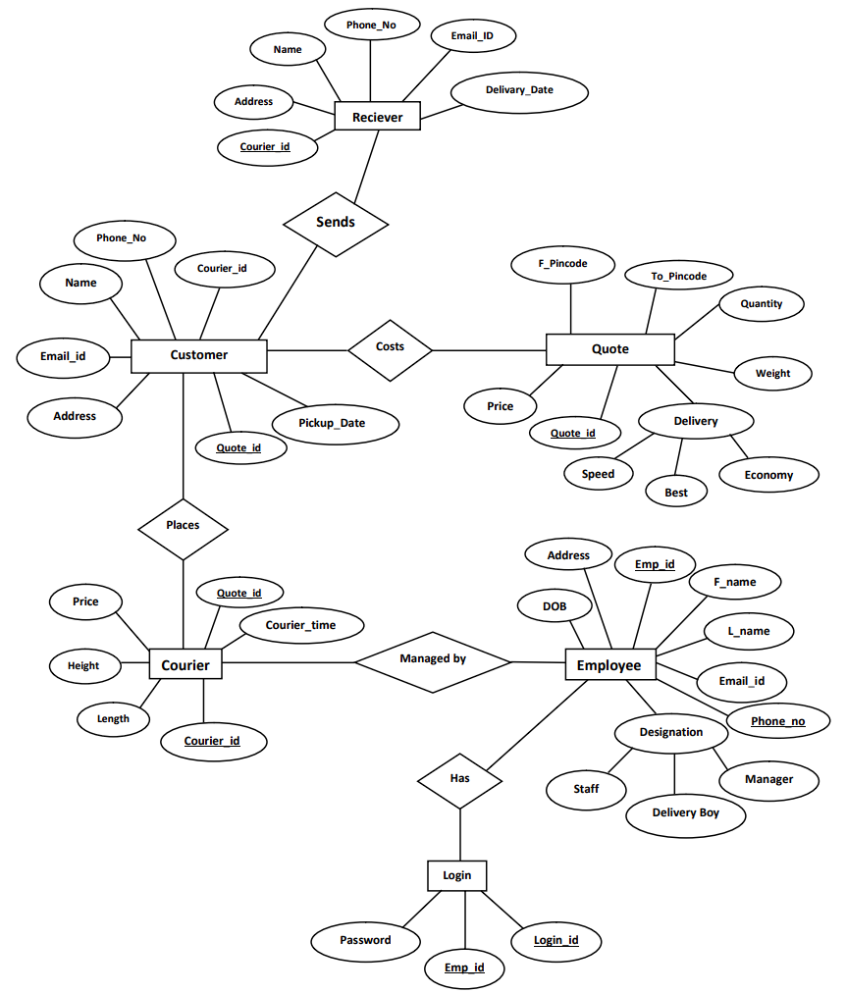

**DATABASE**

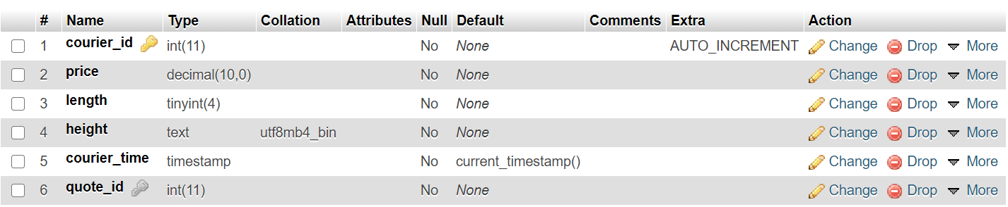COURIER TABLE:-

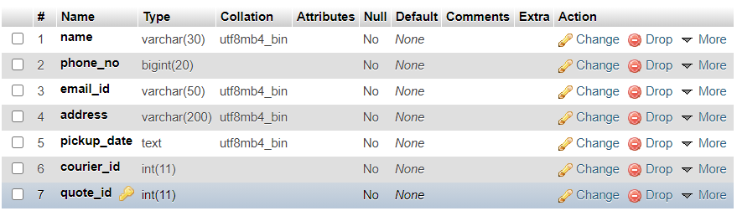CUSTOMER TABLE:-

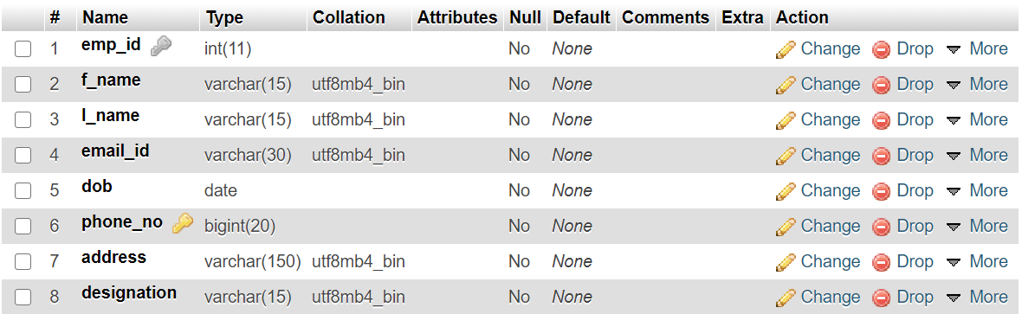EMPLOYEE TABLE:-

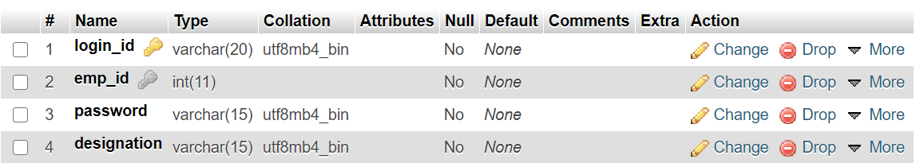LOGIN TABLE:-

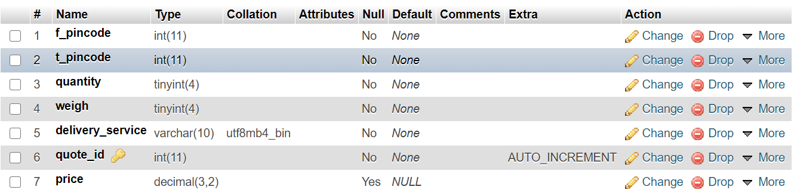QUOTE TABLE:-

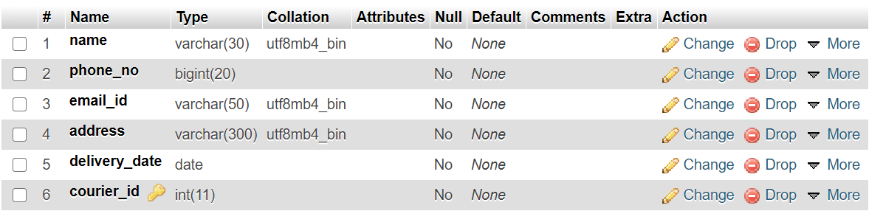RECEIVER TABLE:-

**SCREENSHOTS:-**

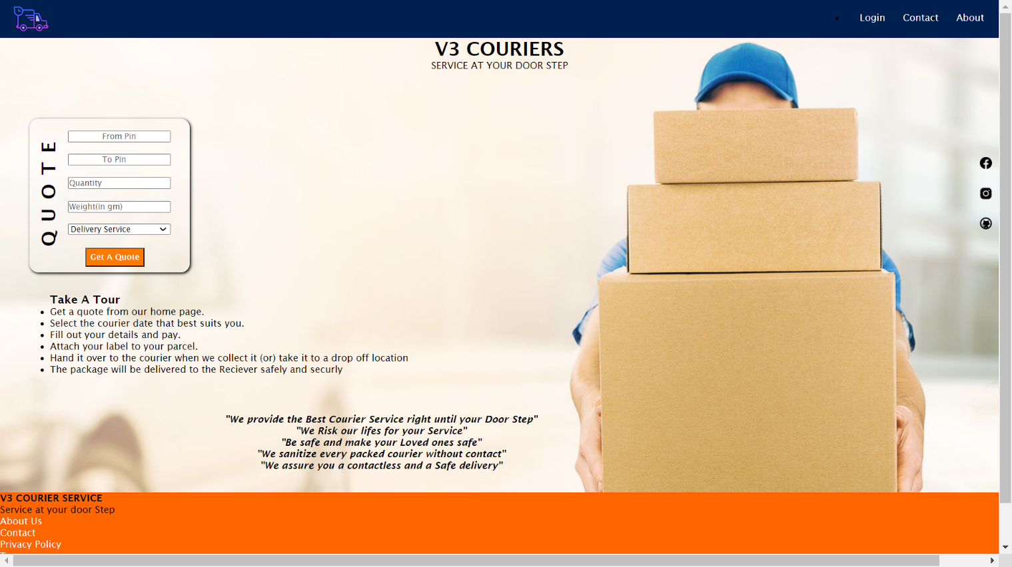HOME PAGE:-

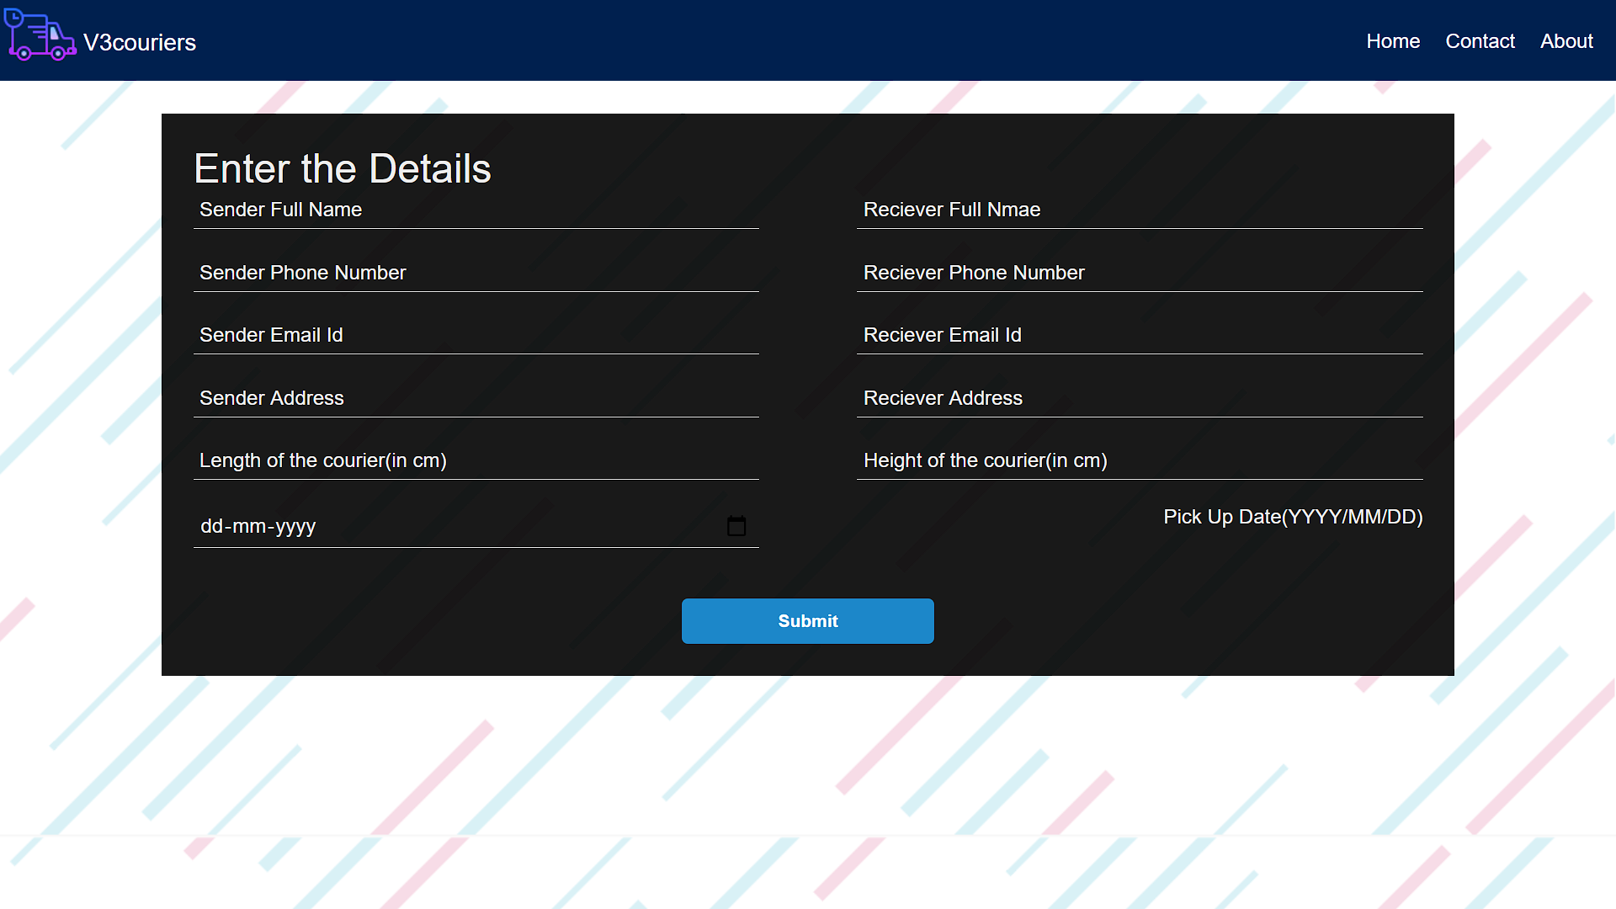DETAILS PAGE:-

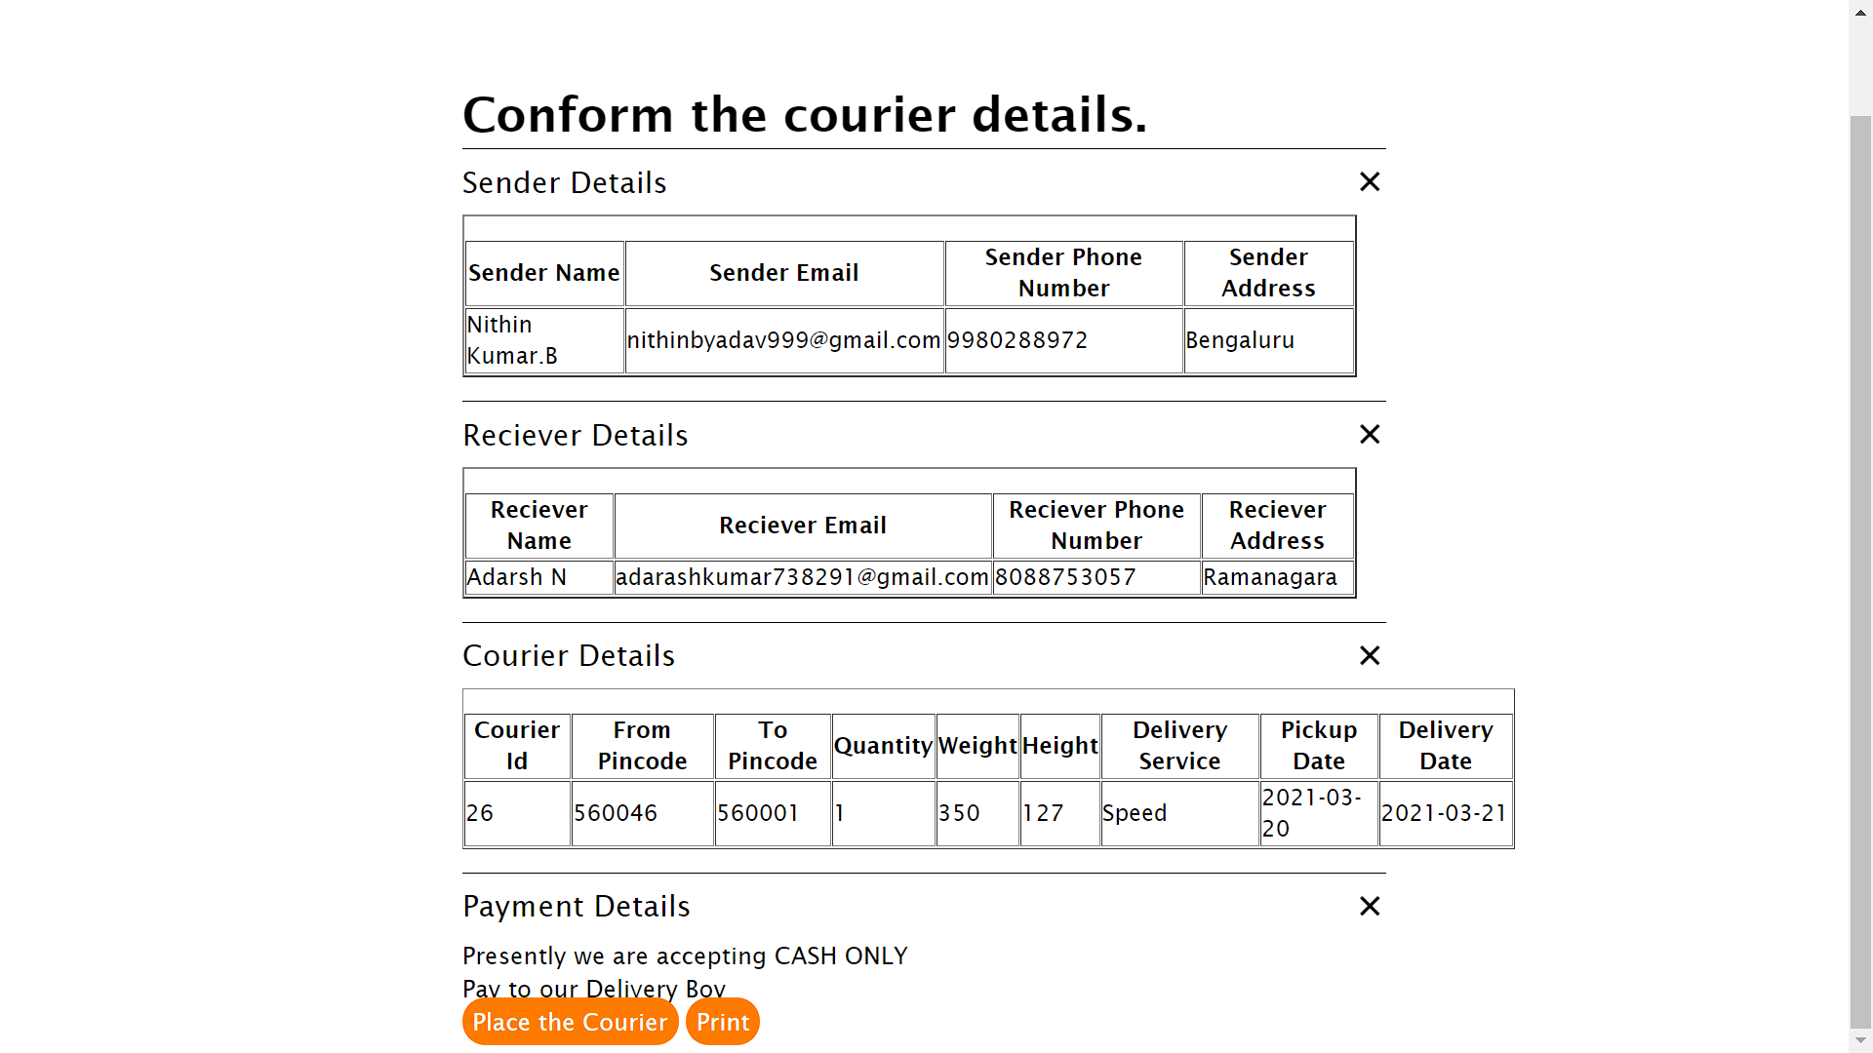SUMMARY PAGE:-

MANAGER LOGIN PAGE:-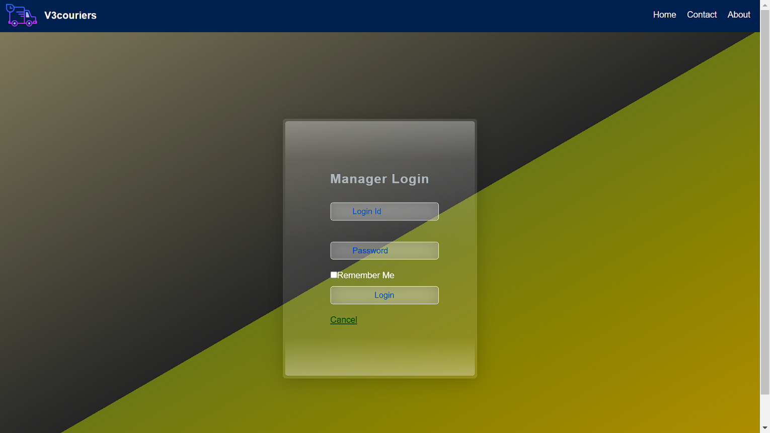

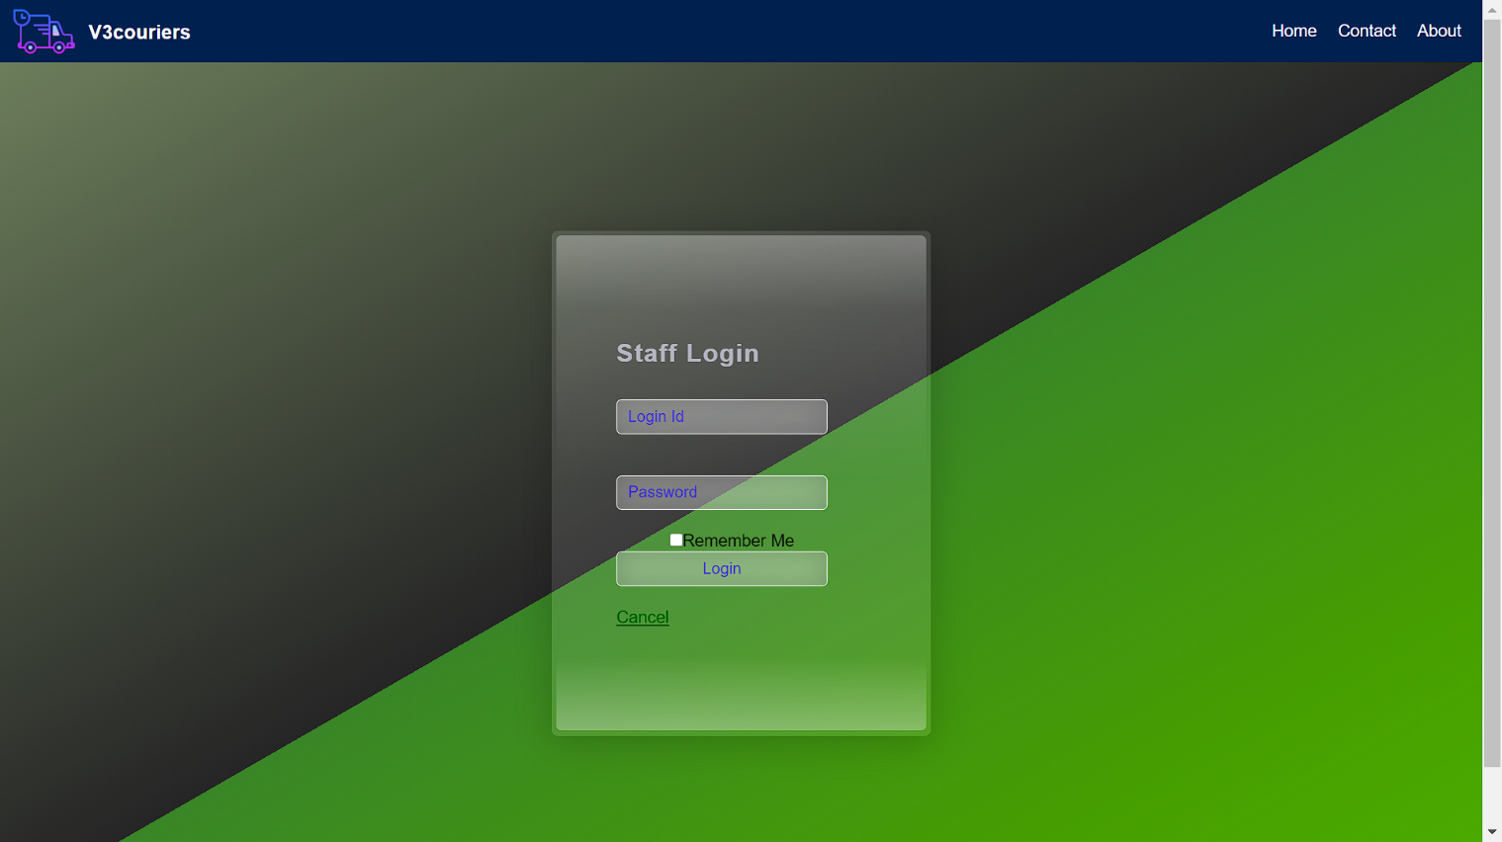STAFF LOGIN PAGE:-

DELIVERY BOY:-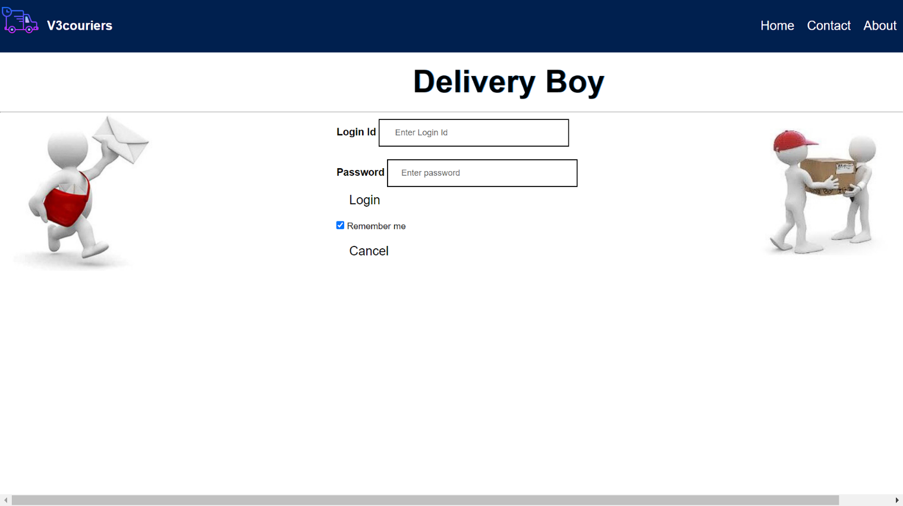

MANAGER HOME PAGE:-

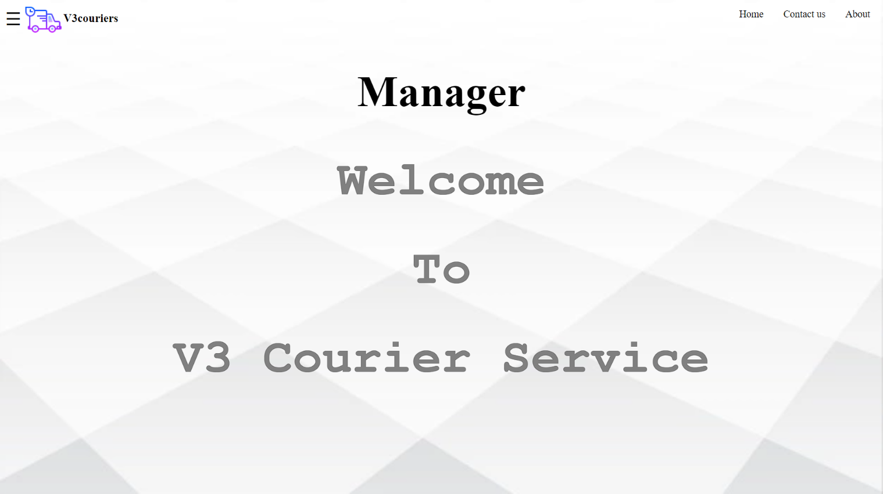

STAFF DETAILS:-

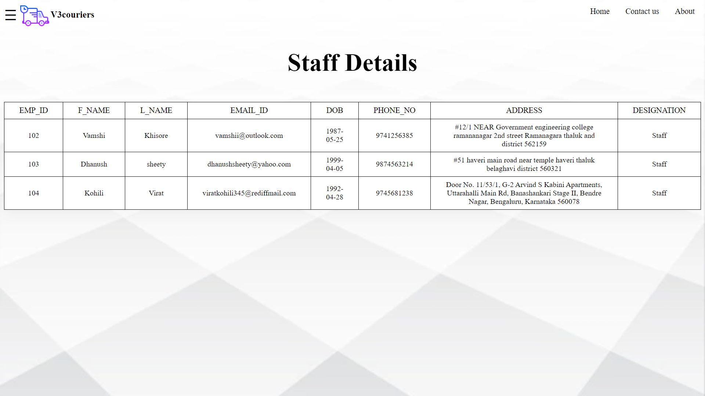

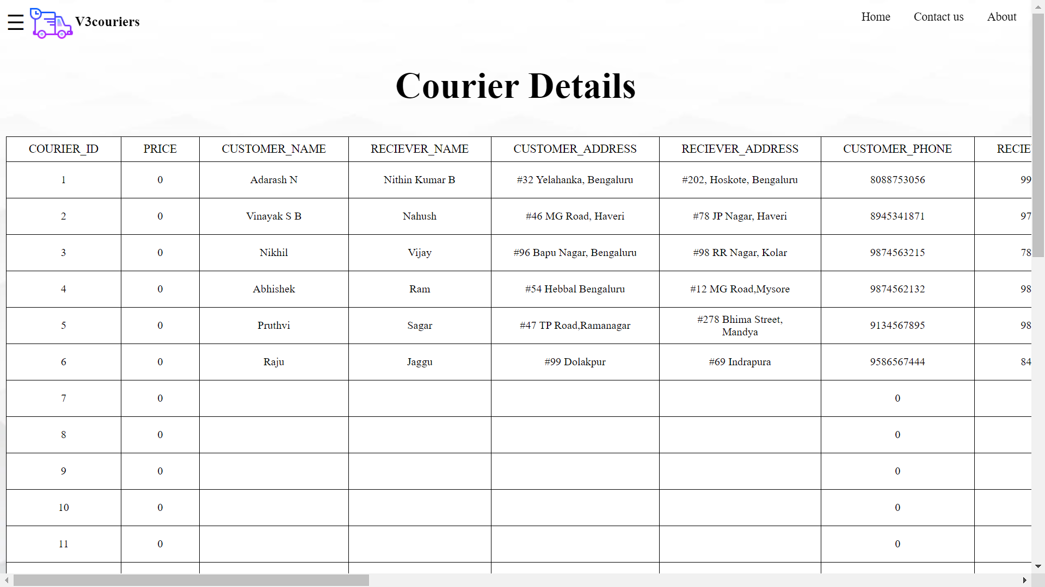COURIER DETAILS:-

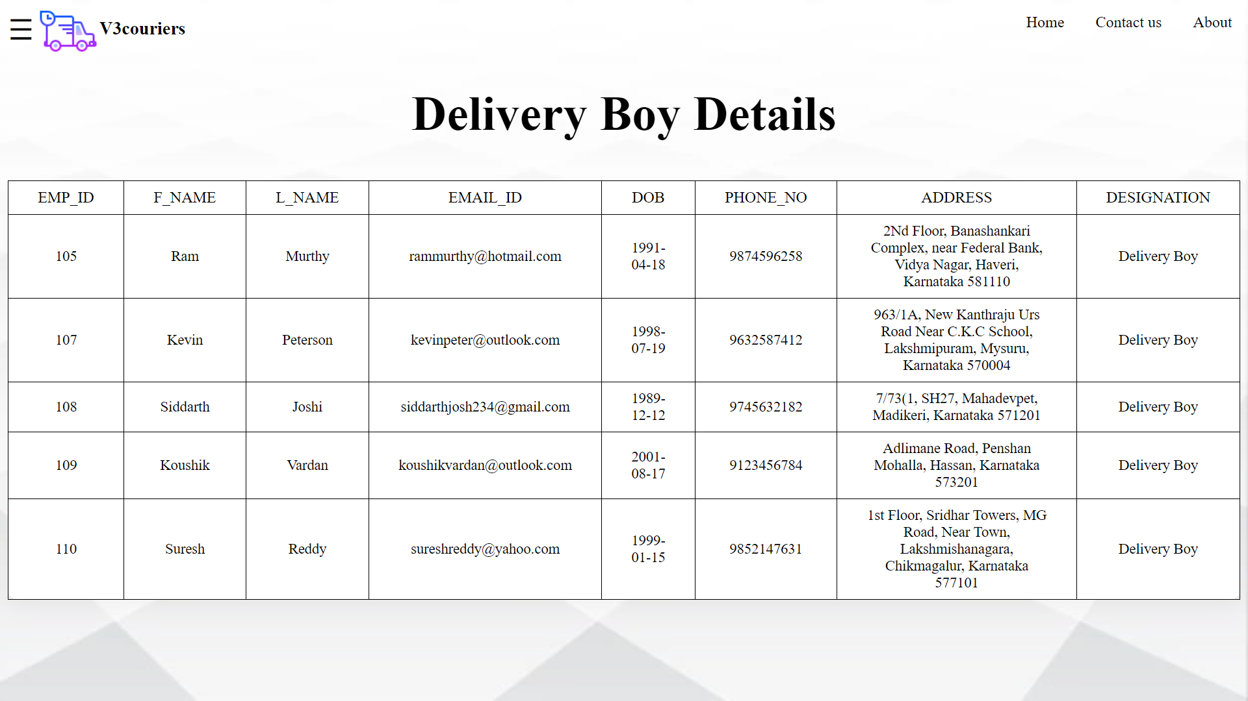DELIVERY BOY DETAILS:-

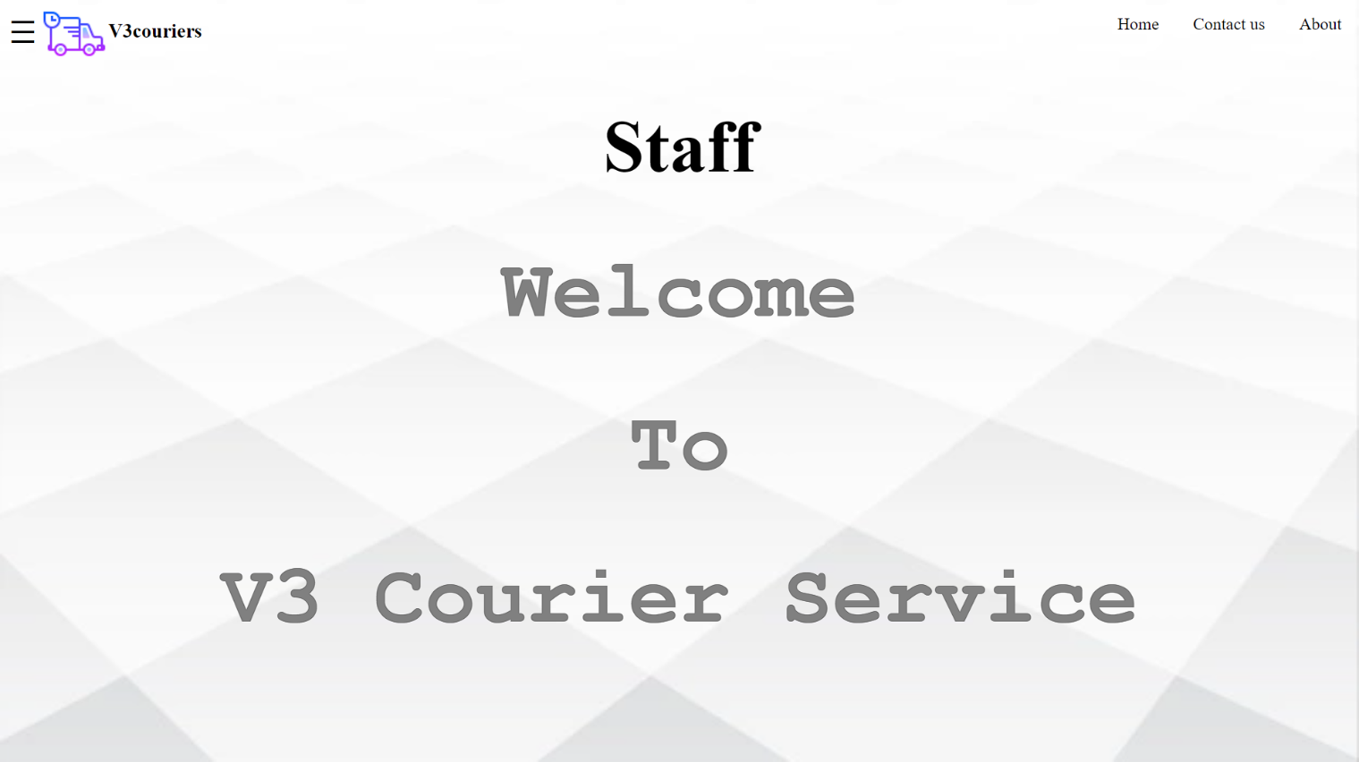STAFF HOME PAGE:-

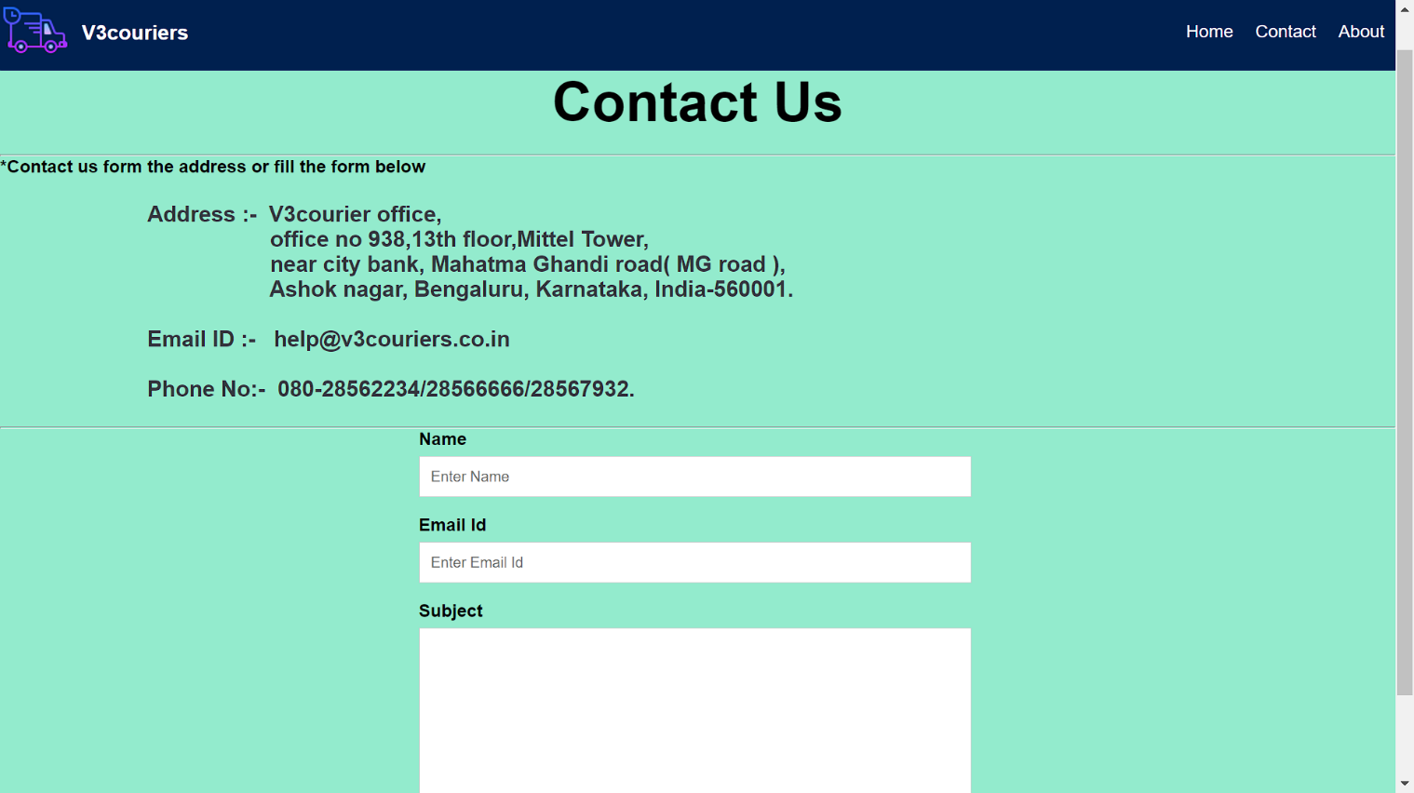Contact Us:-

**SOURCE CODE:-**

-- phpMyAdmin SQL Dump

-- version 5.0.2

-- https://www.phpmyadmin.net/

--

-- Host: 127.0.0.1:3306

-- Generation Time: Jan 05, 2021 at 02:28 PM

-- Server version: 8.0.21

-- PHP Version: 7.3.21

SET SQL_MODE = "NO_AUTO_VALUE_ON_ZERO";

START TRANSACTION;

SET time_zone = "+00:00";

/*!40101 SET @OLD_CHARACTER_SET_CLIENT=@@CHARACTER_SET_CLIENT */;

/*!40101 SET @OLD_CHARACTER_SET_RESULTS=@@CHARACTER_SET_RESULTS */;

/*!40101 SET @OLD_COLLATION_CONNECTION=@@COLLATION_CONNECTION */;

/*!40101 SET NAMES utf8mb4 */;

--

-- Database: `courier`

--

-- --------------------------------------------------------

--

-- Table structure for table `courier`

--

DROP TABLE IF EXISTS `courier`;

CREATE TABLE IF NOT EXISTS `courier` (

`courier_id` int NOT NULL AUTO_INCREMENT,

`price` int NOT NULL,

`customer_name` varchar(30) CHARACTER SET utf8mb4 COLLATE utf8mb4_bin NOT NULL,

`reciever_name` varchar(30) CHARACTER SET utf8mb4 COLLATE utf8mb4_bin NOT NULL,

`customer_address` varchar(150) CHARACTER SET utf8mb4 COLLATE utf8mb4_bin NOT NULL,

`reciever_address` varchar(150) CHARACTER SET utf8mb4 COLLATE utf8mb4_bin NOT NULL,

`customer_phone` bigint NOT NULL,

`reciever_phone` bigint NOT NULL,

`customer_email` varchar(30) COLLATE utf8mb4_bin NOT NULL,

`reciever_email` varchar(30) COLLATE utf8mb4_bin NOT NULL,

`pickup_date` date NOT NULL,

`delivery_date` date NOT NULL,

`f_pincode` mediumint NOT NULL,

`t_pincode` mediumint NOT NULL,

`delivery_service` varchar(15) COLLATE utf8mb4_bin NOT NULL,

`quantity` tinyint NOT NULL,

`weigh` smallint NOT NULL,

`height` tinyint NOT NULL,

`lengt` tinyint NOT NULL,

`picked` tinyint(1) NOT NULL DEFAULT '0',

`delivered` tinyint(1) NOT NULL DEFAULT '0',

`courier_time` timestamp NOT NULL DEFAULT CURRENT_TIMESTAMP,

PRIMARY KEY (`courier_id`)

) ENGINE=InnoDB AUTO_INCREMENT=30 DEFAULT CHARSET=utf8mb4 COLLATE=utf8mb4_bin;

--

-- Dumping data for table `courier`

--

INSERT INTO `courier` (`courier_id`, `price`, `customer_name`, `reciever_name`, `customer_address`, `reciever_address`, `customer_phone`, `reciever_phone`, `customer_email`, `reciever_email`, `pickup_date`, `delivery_date`, `f_pincode`, `t_pincode`, `delivery_service`, `quantity`, `weigh`, `height`, `lengt`, `picked`, `delivered`, `courier_time`) VALUES

(1, 0, 'Adarash N', 'Nithin Kumar B ', '#32 Yelahanka, Bengaluru', '#202, Hoskote, Bengaluru', 8088753056, 9980288979, 'adarashnagaraja@gmail.com', 'nithinb@gmail.com', '2021-01-01', '2021-01-05', 125786, 152165, 'Speed', 2, 127, 124, 124, 0, 0, '2021-01-02 07:39:16'),

(2, 0, 'Vinayak S B', 'Nahush ', '#46 MG Road, Haveri', '#78 JP Nagar, Haveri', 8945341871, 9745438452 , Vinayaksb657@gmail.com', 'nahush@gmail.com', '2021-01-01', '2021-01-05', 123456, 987456, 'Economy', 1, 124, 124, 124, 0, 0, '2021-01-02 07:59:02'),

(3, 0, 'Nikhil', 'Vijay', '#96 Bapu Nagar, Bengaluru', '#98 RR Nagar, Kolar', 9874563215, 7894561235, 'nikhil43785@gmail.com', 'viji3746@gmail.com', '2021-01-01', '2021-01-05', 123456, 987456, 'Economy', 1, 127, 127, 124, 0, 0, '2021-01-02 08:19:07'),

(4, 0, 'Abhishek', 'Ram', '#54 Hebbal Bengaluru', '#12 MG Road,Mysore', 9874562132, 9874561234, 'jahsfkjdhasldjkf@gmail.com', 'jakjfnjsdbfms@gmail.com', '2021-01-01', '2021-01-05', 560064, 561409, 'Economy', 1, 124, 127, 124, 0, 0, '2021-01-02 08:25:50'),

(5, 0, 'Pruthvi', 'Sagar', '#47 TP Road,Ramanagar', '#278 Bhima Street, Mandya', 1234567895, 9874563214, 'nithin@gmail.com', 'zyx@gmail.com', '2021-02-18', '2021-02-19', 560049, 560001, 'Speed', 1, 127, 30, 40, 0, 0, '2021-01-02 09:51:47'),

(6, 0, 'Raju', 'Jaggu', '#99 Dolakpur ', '#69 Indrapura', 9586567444, 8435342319, 'raju@gmail.com', 'jaggut@gmail.com', '2021-01-16', '2021-01-18', 123462, 245542, 'Best', 1, 350, 90, 50, 0, 0, '2021-01-02 10:01:00'),

(7, 0, '', '', '', '', 0, 0, '', '', '0000-00-00', '0000-00-00', 560064, 316564, 'Speed', 32, 124, 0, 0, 0, 0, '2021-01-02 16:56:17'),

(8, 0, '', '', '', '', 0, 0, '', '', '0000-00-00', '0000-00-00', 569999, 560000, 'Speed', 2, 165, 0, 0, 0, 0, '2021-01-02 17:55:50'),

(9, 0, '', '', '', '', 0, 0, '', '', '0000-00-00', '0000-00-00', 569999, 560000, 'Speed', 2, 165, 0, 0, 0, 0, '2021-01-02 17:57:27'),

(10, 0, '', '', '', '', 0, 0, '', '', '0000-00-00', '0000-00-00', 560000, 562145, 'Speed', 2, 15, 0, 0, 0, 0, '2021-01-02 17:57:44'),

(11, 0, '', '', '', '', 0, 0, '', '', '0000-00-00', '0000-00-00', 560064, 560001, 'Speed', 1, 300, 0, 0, 0, 0, '2021-01-02 18:01:08'),

-- --------------------------------------------------------

--

-- Table structure for table `employee`

--

DROP TABLE IF EXISTS `employee`;

CREATE TABLE IF NOT EXISTS `employee` (

`emp_id` int NOT NULL,

`f_name` varchar(15) COLLATE utf8mb4_bin NOT NULL,

`l_name` varchar(15) COLLATE utf8mb4_bin NOT NULL,

`email_id` varchar(30) COLLATE utf8mb4_bin NOT NULL,

`dob` date NOT NULL,

`phone_no` bigint NOT NULL,

`address` varchar(150) COLLATE utf8mb4_bin NOT NULL,

`designation` varchar(15) COLLATE utf8mb4_bin NOT NULL,

PRIMARY KEY (`phone_no`) USING BTREE,

KEY `emp_id` (`emp_id`)

) ENGINE=InnoDB DEFAULT CHARSET=utf8mb4 COLLATE=utf8mb4_bin;

--

-- Dumping data for table `employee`

--

INSERT INTO `employee` (`emp_id`, `f_name`, `l_name`, `email_id`, `dob`, `phone_no`, `address`, `designation`) VALUES

(109, 'Koushik', 'Vardan', 'koushikvardan@outlook.com', '2001-08-17', 9123456784, 'Adlimane Road, Penshan Mohalla, Hassan, Karnataka 573201', 'Delivery Boy'),

(107, 'Kevin ', 'Peterson', 'kevinpeter@outlook.com', '1998-07-19', 9632587412, '963/1A, New Kanthraju Urs Road Near C.K.C School, Lakshmipuram, Mysuru, Karnataka 570004', 'Delivery Boy'),

(102, 'Vamshi', 'Khisore', 'vamshii@outlook.com', '1987-05-25', 9741256385, '#12/1 NEAR Government engineering college ramananagar 2nd street Ramanagara thaluk and district 562159\r\n ', 'Staff'),

(108, 'Siddarth', 'Joshi', 'siddarthjosh234@gmail.com', '1989-12-12', 9745632182, '7/73(1, SH27, Mahadevpet, Madikeri, Karnataka 571201', 'Delivery Boy'),

(104, 'Kohili', 'Virat', 'viratkohili345@rediffmail.com', '1992-04-28', 9745681238, 'Door No. 11/53/1, G-2 Arvind S Kabini Apartments, Uttarahalli Main Rd, Banashankari Stage II, Bendre Nagar, Bengaluru, Karnataka 560078', 'Staff'),

(110, 'Suresh', 'Reddy', 'sureshreddy@yahoo.com', '1999-01-15', 9852147631, ' 1st Floor, Sridhar Towers, MG Road, Near Town, Lakshmishanagara, Chikmagalur, Karnataka 577101', 'Delivery Boy'),

(101, 'Ramesh ', 'Kumar', 'rameshkumar876@gmail.com', '1999-09-09', 9856327418, '#234, 1st main , 25th cross , mig 2nd stage, yelahanka new town Bangalore north Bangalore Urban 560064', 'Manager'),

(103, 'Dhanush', 'sheety', 'dhanushsheety@yahoo.com', '1999-04-05', 9874563214, '#51 haveri main road near temple haveri thaluk belaghavi district 560321', 'Staff'),

(105, 'Ram', 'Murthy', 'rammurthy@hotmail.com', '1991-04-18', 9874596258, '2Nd Floor, Banashankari Complex, near Federal Bank, Vidya Nagar, Haveri, Karnataka 581110', 'Delivery Boy');

-- --------------------------------------------------------

--

-- Table structure for table `login`

--

DROP TABLE IF EXISTS `login`;

CREATE TABLE IF NOT EXISTS `login` (

`login_id` varchar(20) CHARACTER SET utf8mb4 COLLATE utf8mb4_bin NOT NULL,

`emp_id` int NOT NULL,

`password` varchar(15) COLLATE utf8mb4_bin NOT NULL,

`designation` varchar(15) COLLATE utf8mb4_bin NOT NULL,

PRIMARY KEY (`login_id`) USING BTREE,

KEY `emp_id` (`emp_id`)

) ENGINE=InnoDB DEFAULT CHARSET=utf8mb4 COLLATE=utf8mb4_bin;

--

-- Dumping data for table `login`

--

INSERT INTO `login` (`login_id`, `emp_id`, `password`, `designation`) VALUES

('dhanush@v3courier', 103, 'Dhanush345@', 'Staff'),

('kevin@v3courier', 107, 'Kevin987@', 'Delivery Boy'),

('kohili@v3courier', 104, 'Kohili123@', 'Staff'),

('koushik@v3courier', 109, 'Koushik765@', 'Delivery Boy'),

('ramesh@v3courier', 101, 'Ramesh987@', 'Manager'),

('rammurthy@v3courier', 105, 'Rammurthy567@', 'Delivery Boy'),

('siddarth@v3courier', 108, 'Siddarth986@', 'Delivery Boy'),

('sumeedh@v3courier', 106, 'Sumeedh653@', 'Delivery Boy'),

('suresh@v3courier', 110, 'Suresh765@', 'Delivery Boy'),

('vamshi@v3courier', 102, 'Vamshi456@', 'Staff');

--

-- Constraints for dumped tables

--

--

-- Constraints for table `employee`

--

ALTER TABLE `employee`

ADD CONSTRAINT `emp_id` FOREIGN KEY (`emp_id`) REFERENCES `login` (`emp_id`) ON DELETE RESTRICT ON UPDATE CASCADE;

COMMIT;

/*!40101 SET CHARACTER_SET_CLIENT=@OLD_CHARACTER_SET_CLIENT */;

/*!40101 SET CHARACTER_SET_RESULTS=@OLD_CHARACTER_SET_RESULTS */;

/*!40101 SET COLLATION_CONNECTION=@OLD_COLLATION_CONNECTION */;

**CONCLUSION**

Computer has got clear advantage over the manual system. The computerized system is more reliable, efficient and fast at the end of the project, | can say that computer play a very crucial role in the development of firm. All the daily reports generated by the system are to be checked by the concerned official so as to ensure that all the transactions have been put through in appropriate accounts and this is tallied with the new vouchers.

Computer does maximum work with in minimum time. Because it is used in every field so that it provides comfort and suitability to everyone. Providing maximum facilities and comfort to customers to customers is main goal of the firm. To achieve this goal, other modern facilities relating to computer should have to be provided.

**BIBLIOGRAPHY**

**Books :**

* Fundamentals of Database System
* Database Management System
* A Smarter Way to Learn JavaScript
* The Truth About HTML5
* The Essential Guide to CSS and HTML Web Design

**Websites:**

* [www.w3schools.com](http://www.w3schools.com)
* [www.javapoint.com](http://www.javapoint.com)
* [www.freecodecamp.org](http://www.freecodecamp.org)
* [www.stackoverflow.com](http://www.stackoverflow.com)
* [www.youtube.com](http://www.youtube.com)

**Search Engines:**

* [www.google.com](http://www.google.com)
* [www.bing.com](http://www.bing.com)
* [www.duckduckgo.com](http://www.duckduckgo.com)